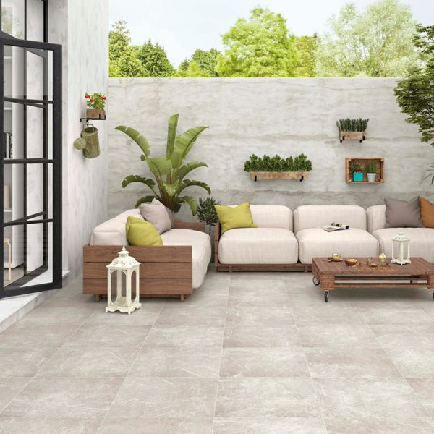**Medici Plus Natural Porcelain Paving Slabs:**

## **Product Description**

Transform your garden into a relaxing and functional space with the simple addition of these Medici Plus Natural 60x60 Tiles. Made from 20mm porcelain, these tiles are durable, long-lasting and frost-proof, and they have a stone effect look, which is alive with delicate veining and fossilising. They offer a warm blend of natural beiges, creating a variety of tones. 20mm Paving Trims?

**What's special about these tiles?**

> 20mm thick durable porcelain

> Realistic stone effect design

> Long lasting and frostproof

> Perfect for creating a stylish patio space

**Have you seen our selection of Norcross Rock-Tite products? They're perfect for fixing and completing outdoor projects!**

## **Product INFO**

* Product ID44179
* Tiles Per SQM 2.8246592754749
* Sale by Per SQM
* Size 595x595x20mm
* Weight 13.75 KG
* Material Type Porcelain
* Finish Matt
* Colour Grey
* Suitability Floors
* Area Of Usage External
* Grade 4
* Rectified Edge Yes
* Underfloor Heating Yes
* Anti Slip Grade R11 / 12 Degrees
* Document [20mm Installation Guide](https://m2.wallsandfloors.co.uk/media/amasty/amfile/attach/20mm-installation-guide_4.pdf),[Cleaning and Protection Guide](https://m2.wallsandfloors.co.uk/media/amasty/amfile/attach/ltp_-_walls_floors_-_external_porcelain_-_cleaning_and_protection_guide_-_april_2020.pdf)
* Thickness (mm) 20